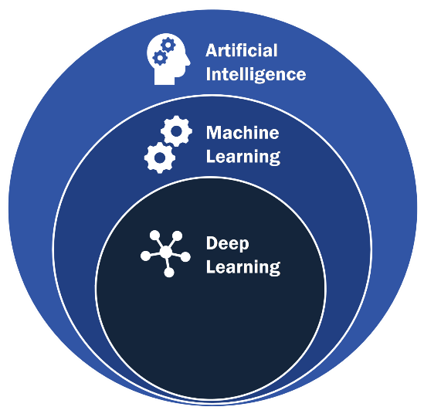

Expert System Jo hai Vo Close chizo pe kaam krta hai bss yeahi flaw hai uska

But Fuzzy Problem mai atakjaata hai lyk

Voice, Image Classification etc

ML Types:

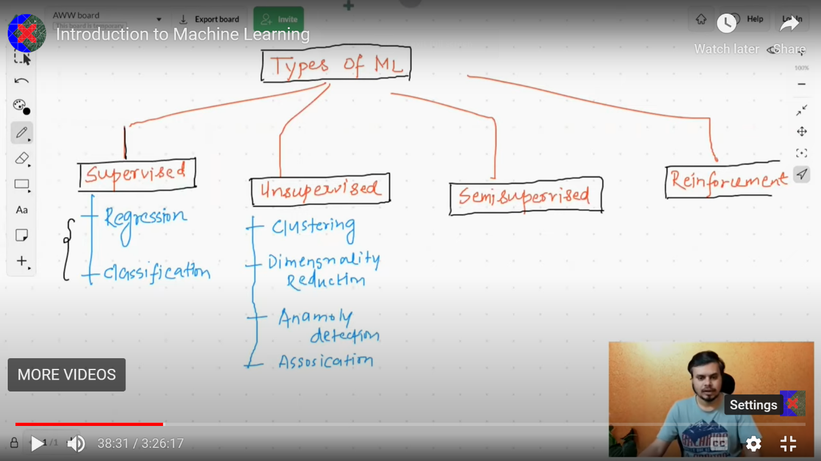

*Supervised Learning*

If student ka data hai E.g: Iq & CGPA & output data hai ki Placement hua ki nahi

Most of the time Supervised hie use krte hai hum for work.

*Numerical Data kesath Deal karnekeliye we use Regression.*

*Categorical Data kesath we use Classification*

***Unsupervised ML***

***Unsupervise mai bss input hota hai humarepass***

***So isliye hum mostly 4 chiz krte Unsupervised Learning mai***

1. ***Clustering***
2. ***Dimensionality Reduction***

***Dimensionality Reduction***

***Kabhi kabhi kya hota hai ki jo input data jo hota hai or kya hota ki***

***Input Columns bhaut saare hojate hai.***

***Ishse problem hoti hai ki***

1. ***Algo slow hojata hai***
2. ***& ek Level kebaad humme aur Input Columns ki need nahi hoti so that’s why***

***Hum yeah technique use karke***

***Hum Extra Columns nikaalte hai. Yeah balki kya karega sbh related column se 1 akela***

***Column banadiya***

***Yaha 1 Algo hota hai called as PCA.***

1. ***Anomoloy Detection***
2. ***Association Rule Learning***

*Reinforcement Learning*

